.
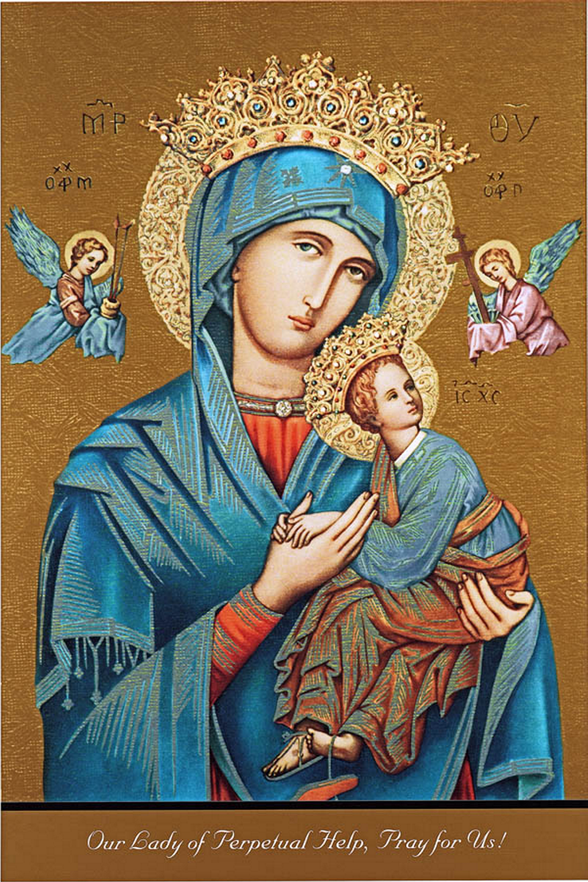 | September 2023
Sun. | Mon. | Tue. | Wed. | Thu. | Fri. | Sat.
 |  |  |  |  | 1 | 2
 |  |  |  |  | First Friday  9:30 Adoration, Confession & Mass @ St Roch | First Saturday  9:30 Adoration, Confession & Mass @ St Francis  5:00 Mass offered for Mary Schaefer
3 | 4 | 5 | 6 | 7 | 8 | 9
8:30 Mass  10:30 Mass |  | 6:00 Mass @ St Roch  6:30 Finance Council | 8:45 Bible Study  10:00 Mass @ St Francis  11:00 Women’s Society Meeting | 10:00 Mass @ St Roch  6:00 Pastoral Council |  | 5:00 Mass  40 years + Anniversary Celebration 6:00
10 | 11 | 12 | 13 | 14 | 15 | 16
8:30 Mass  10:30 Mass  5:00 pm Mass in Ubly |  | 6:00 PM Mass @ St Roch Mass offered for  Pomponii & Discennna Families | 8:45 Bible Study  10:00 Mass @ St Francis | 10:00 Mass @ St Roch & After Mass Coffee |  | 5:00 Mass  Mass offered for John Adam Schaefer
17 | 18 | 19 | 20 | 21 | 22 | 23
8:30 Mass  10:30 Mass offered for Christopher Discenna |  | 6:00 PM Mass @ St Roch | 8:45 Bible Study  10:00 Mass @  St Francis | 10:00 Mass offered for Robert and Molly Oaks @ St Roch & After Mass Coffee |  | 5:00 Mass
24 | 25 | 26 | 27 | 28 | 29 | 30
10:30 Mass offered for Mary Jane Voelker |  |  | 8:45 Bible Study  10:00 Communion Service @ St Francis | No Mass |  | 5:00 Mass
31 |  |  | Saginaw Diocese Priest Assembly

Notes | WEEKEND MASS SCHEDULE  Saturday Mass 5:00 PM St Roch Church in Caseville  Sunday Mass 8:30 AM St Roch Church in Caseville  Sunday Mass 10:30 AM St Francis Borgia Church in Pigeon  All activities on the Parish Calendar Occur in the Parish Center unless otherwise stated.

